PROJECT REPORT
Auto Ticket Classification using ServiceNow Flow Designer
Student Project: School IT Helpdesk Automation
Item | Details
Team Lead | Dakshayani R N R
Team Members | Harini Sri S, Rubiga I
Platform | ServiceNow (Flow Designer, Global scope)
Date | 08 October 2026
Team ID | 9100RootAccess

Companion documents: Problem – Solution Fit, Proposed Solution and Solution Architecture (project design phase) and the Project Documentation.

1. INTRODUCTION

1.1 Project Overview
A school IT helpdesk receives many incident requests every day from students and teachers. Typical examples are Wi-Fi problems, projector failures, forgotten passwords and slow computers. Until now, staff had to read each request and choose its category by hand.
This project automates that step. On the ServiceNow platform, a no-code Flow Designer flow reads the Short Description of a new ticket, matches it against keywords, fills the Category and Subcategory, and sends a confirmation email to the caller. The work was organised into five epics (milestones) and twelve tasks shared by a three-member team.

1.2 Purpose
The purpose of the project is to make ticket handling faster and more consistent while keeping the solution simple enough for a school team to maintain. The specific goals are to:
- Classify an incident automatically at the moment it is created.
- Reduce manual work for IT staff.
- Make ticket routing more consistent.
- Keep the solution no-code and easy to maintain.

2. IDEATION PHASE

2.1 Problem Statement
 | Requester (student / teacher) | IT helpdesk staff
I am | A student or teacher who depends on school IT. | A member of the school IT helpdesk.
I'm trying to | Report a problem and get it fixed quickly. | Log, categorise and route every request.
But | I cannot tell if my request was received or categorised correctly. | I must read each ticket, pick a category and subcategory, and inform the caller.
Because | Classification is done manually and the queue grows. | No automation exists and request volume keeps increasing.
Which makes me feel | Unsure and frustrated. | Overloaded and worried about errors.

2.2 Empathy Map Canvas
 | Requester (student / teacher) | IT helpdesk staff
Says | "My Wi-Fi is not working." "Did anyone get my request?" | "Another ticket to sort." "Which category is this?"
Thinks | Will my issue reach the right person? Is it worth following up? | Manual sorting is slow and I may pick the wrong category.
Does | Reports the issue, waits, and follows up for status. | Reads each ticket, selects category and subcategory, informs the caller.
Feels | Anxious, impatient, lost until confirmation arrives. | Pressured by volume; relieved when routine work is handled for them.

2.3 Brainstorming
The team evaluated several ideas before choosing the approach.
Idea | Assessment | Decision
Manual checklist for staff | Helps consistency but the work stays manual. | Rejected
Scripted business rule | Possible, but needs code and developer skill to maintain. | Rejected
Keyword rules in Flow Designer | No-code, visual, and easy to extend. | Selected
Dependent Category / Subcategory lists | Prevents invalid category pairs. | Selected
Automatic confirmation email | Gives callers immediate reassurance. | Selected
Predictive Intelligence (machine learning) | Powerful, but needs training data. | Deferred to future scope

3. REQUIREMENT ANALYSIS

3.1 Customer Journey Map
Stage | Requester action | System response | Emotion
Problem occurs | Notices Wi-Fi, projector, login or speed issue. | - | Frustrated
Report | Opens the Incident WorkFlow form and enters Caller and Short Description. | Record saved with an INC number. | Hopeful
Classification | No action needed. | Flow matches keywords and sets Category and Subcategory. | Neutral
Confirmation | Receives the email. | Send Email action notifies the caller. | Reassured
Resolution | Waits for IT staff. | Staff see a correctly classified ticket. | Confident

3.2 Solution Requirement
ID | Type | Requirement
FR1 | Functional | Automatically classify IT tickets from the issue description.
FR2 | Functional | Assign both Category and Subcategory without manual intervention.
FR3 | Functional | Support dependent choices between Category and Subcategory.
FR4 | Functional | Send an automatic email to the caller after ticket creation.
FR5 | Functional | Store ticket details in a structured format.
NFR1 | Non-functional (maintainability) | Be easy to maintain and extend later, using no scripts.
NFR2 | Non-functional (usability) | Requester supplies only the Caller and Short Description.
NFR3 | Non-functional (portability) | Configuration is packaged in an update set that can move to another instance.

3.3 Data Flow Diagram
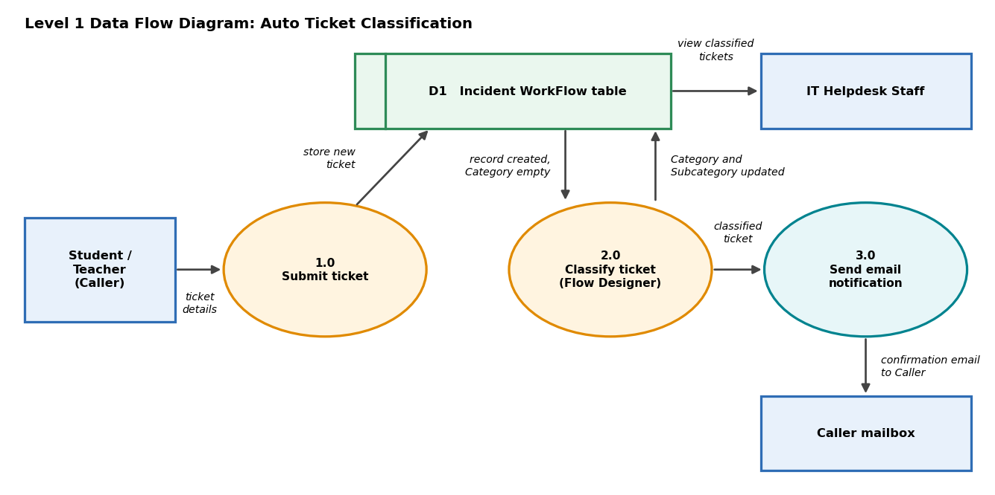
Figure 1: Level 1 data flow diagram
Process 1.0 stores the caller's ticket details in data store D1. Process 2.0 is triggered by the new record, reads the Short Description and writes the Category and Subcategory back to D1. Process 3.0 sends the confirmation email to the caller, and IT staff read the classified tickets from D1.

3.4 Technology Stack
Layer | Technology / tool
Platform | ServiceNow instance, Global application scope
Data model | Custom table Incident WorkFlow (u_incident_workflow), Form Designer, dictionary entries and choice lists
Automation | Flow Designer in Workflow Studio: Record Created trigger, If / Else If logic, Update Record action
Notification | Send Email action, SMTP delivery, System Logs > Emails for verification
Packaging | Local update set (Project Update Set) exported to XML
Client | Standard web browser

4. PROJECT DESIGN
The design-phase artefacts were prepared as separate documents. Each is summarised here and not repeated.

4.1 Problem Solution Fit
The filled canvas maps the customer segments, constraints, triggers and emotions to the automated classification solution. See Problem_Solution_Fit_Auto_Ticket_Classification.docx.

4.2 Proposed Solution
Sets out the problem statement, idea, novelty, impact, business model and scalability, together with the field configuration and flow rules. See Proposed_Solution_Auto_Ticket_Classification.docx.

4.3 Solution Architecture
Shows the architecture diagram, components, data flow, validation and deployment. See Solution_Architecture_Auto_Ticket_Classification.docx.

5. PROJECT PLANNING & SCHEDULING

5.1 Project Planning
Work was tracked on the project Kanban board with five epics and twelve tasks, no subtasks, and no mentor assigned at the time of capture. Every task is rated Easy, and all twelve sit in the "To Be Reviewed" column.
Epic / Milestone | Task | Owner | Duration | Level
1. Requirement Analysis & Planning | Activity 1: Business Use Case | Dakshayani R N R | 5m | Easy
 | Activity 2: Creation of New Update Set | Harini Sri S | 5m | Easy
 | Activity 3: Navigation steps in Picture View | Rubiga I | 5m | Easy
2. Backend Development & Configuration | Activity 1: Creation of Custom Table to Store Tickets | Harini Sri S | 5h 50m | Easy
 | Activity 2: Field Creation and Data Type Configuration | Dakshayani R N R | 1h 10m | Easy
 | Activity 3: Implementing Dependency Between Category and Subcategory | Rubiga I | 0m | Easy
3. Automation using Flow Designer & Email Notification | Activity 1: Auto Classification using Flow Design | Rubiga I | 5h 0m | Easy
4. Testing, Validation & Security | Activity 1: Test Scenario 1 | Dakshayani R N R | 5m | Easy
 | Activity 2: Test Scenario 2 | Rubiga I | 5m | Easy
 | Activity 3: Test Scenario 3 | Harini Sri S | 5m | Easy
5. Deployment & Conclusion | Activity 1: Make Update Set to Complete State | Dakshayani R N R | 5m | Easy
 | Conclusion | Harini Sri S | 5m | Easy

Workload by team member (four tasks each):
Team member | Role | Estimated effort
Dakshayani R N R | Team Lead | 1h 25m
Harini Sri S | Member | 6h 05m
Rubiga I | Member | 5h 10m
Total | 12 tasks | 12h 40m

6. FUNCTIONAL AND PERFORMANCE TESTING

6.1 Performance Testing
Detailed functional test scenarios are recorded in the Solution Architecture document. This section judges the finished solution against its performance goals.
Measure | Before (manual) | After (automated)
Staff actions per ticket | Three: identify issue, choose Category and Subcategory, inform caller. | None; the flow classifies and notifies.
Requester input | Free description handled by staff. | Two fields: Caller and Short Description.
Classification trigger | When a staff member gets to the ticket. | Immediately on record creation.
Consistency | Depends on the person reading. | Same keyword rules applied every time.
Records verified | - | Network ticket and projector ticket classified correctly; confirmation emails logged as send-ready over SMTP.

Flow execution time and large-volume behaviour were not measured in this project. The Flow Designer execution details can be used to record them in a follow-up test.

7. RESULTS

7.1 Output Screenshots
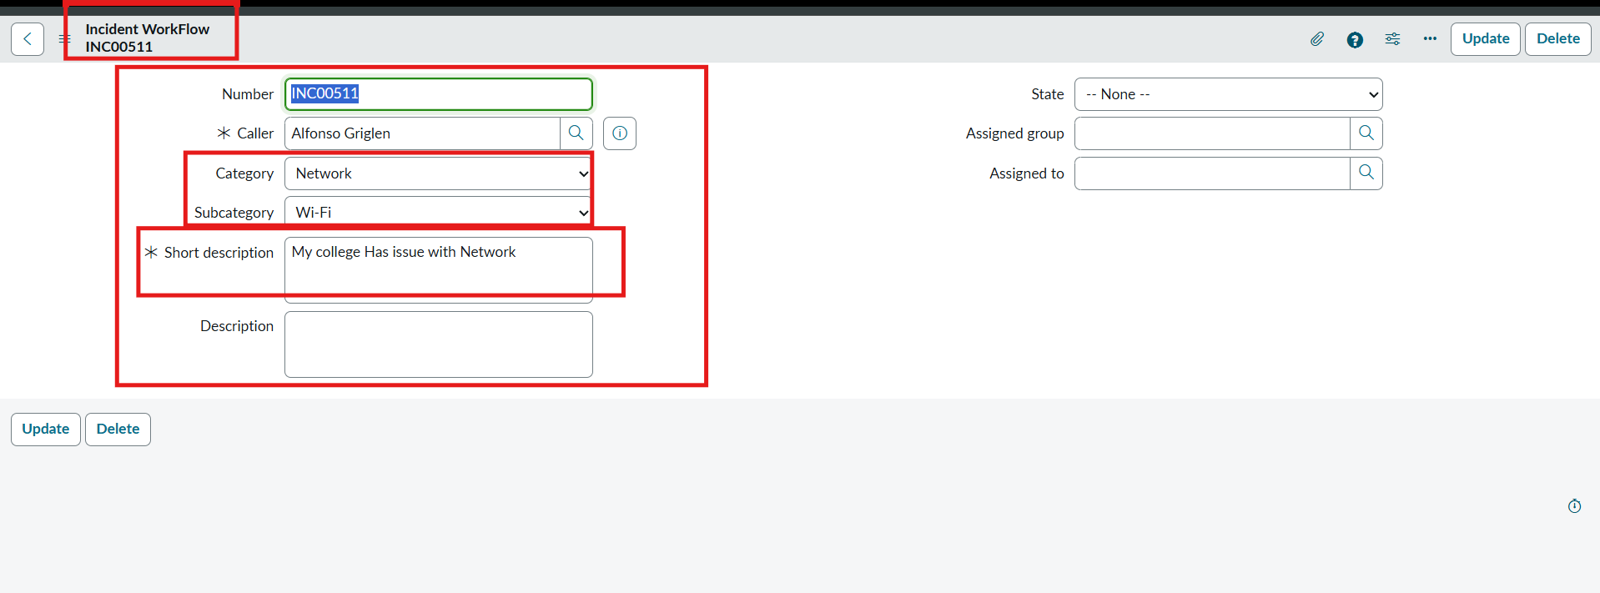
Figure 2: Network ticket automatically classified as Network / Wi-Fi
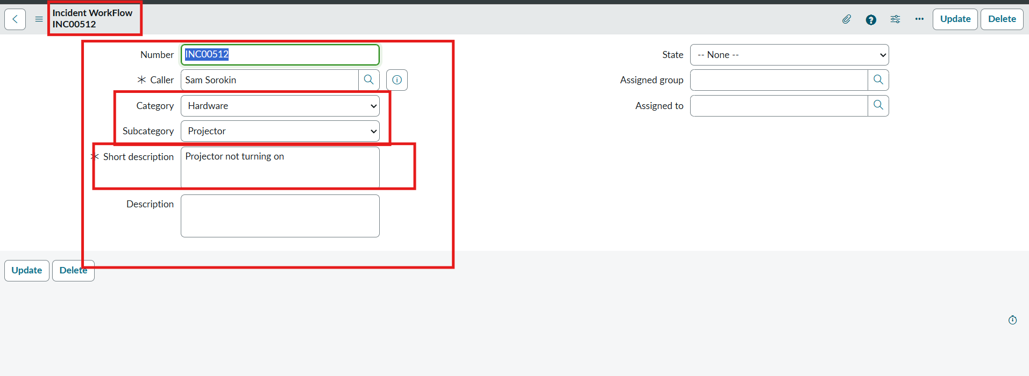
Figure 3: Projector ticket automatically classified as Hardware / Projector
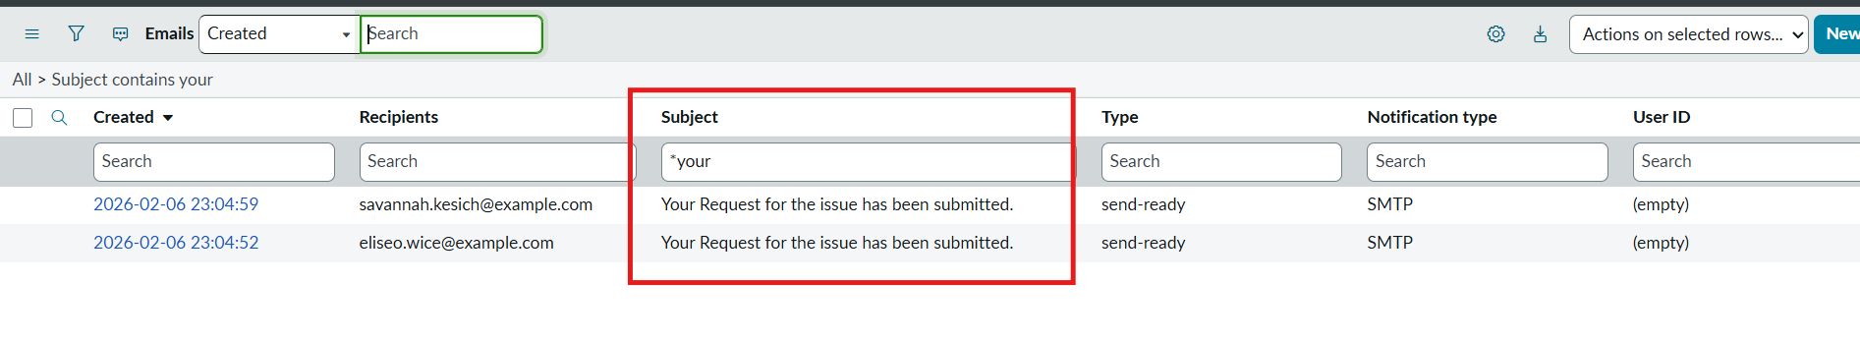
Figure 4: Confirmation emails listed in System Logs > Emails
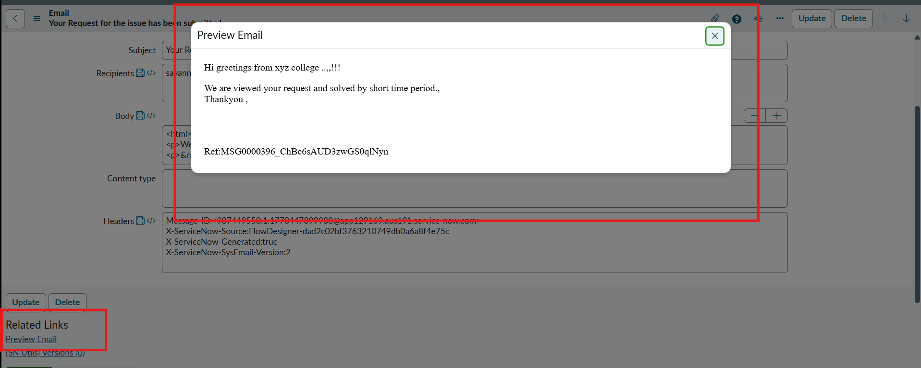
Figure 5: Preview of the confirmation email received by the caller
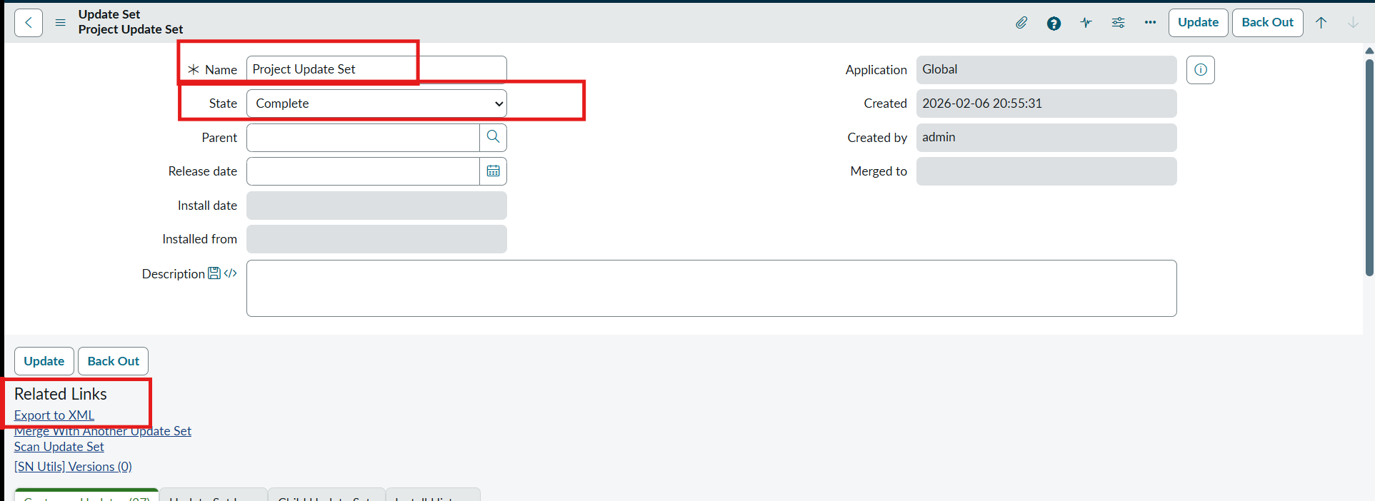
Figure 6: Project Update Set moved to Complete, with Export to XML available

8. ADVANTAGES & DISADVANTAGES
Advantages | Disadvantages
Cuts the manual sorting effort of IT staff.  Gives consistent classification every time.  Callers get an immediate confirmation email.  No-code, so non-developers can maintain it.  Dependent lists keep stored data valid.  Runs on the existing instance with no extra licence.  Update set makes it portable. | Rule-based: depends on the exact words in the description.  Covers only four issue types at present.  Tickets that match no keyword stay unclassified.  Order of conditions affects the outcome.  Email delivery relies on the instance mail setup.  Tested on a small sample of tickets.

9. CONCLUSION
The team completed all twelve tasks across five milestones and moved them to review. The finished solution meets each stated objective: tickets are classified at creation, staff effort per ticket is reduced, routing is more consistent, and the whole design remains no-code. Working in clearly assigned milestones also let the team check configuration, testing and deployment step by step.

10. FUTURE SCOPE
Enhancement | Benefit | Builds on
Assignment automation | Route each ticket straight to the right group and technician. | Assigned group and Assigned to fields
SLA tracking | Measure and enforce response and resolution times. | State field and ticket timestamps
Predictive Intelligence | Classify by learning from past tickets instead of fixed keywords. | Structured ticket history in the table

11. APPENDIX
- Source Code: Not applicable; the solution is built with configuration and Flow Designer, with no custom scripts. The exported Project Update Set (XML) serves as the deliverable.
- Dataset Link: Not applicable; test tickets were created directly in the Incident WorkFlow table.
- GitHub Link: https://github.com/daks97/Naan-Mudhalvan
- Project Demo Link: https://drive.google.com/file/d/1uO2VirRaVhmERC1MEWYeHINCg_ftV8Lo/view?usp=drivesdk

